**Task 1**

In this first task you need to create a new procedure called **AddBooking** to add a new table booking record.

The procedure should include four input parameters in the form of the following bookings parameters:

* booking id,
* customer id,
* booking date,
* and table number.

## ****Task 2****

For your second task, Little Lemon need you to create a new procedure called **UpdateBooking** that they can use to update existing bookings in the booking table.

The procedure should have two input parameters in the form of booking id and booking date. You must also include an **UPDATE** statement inside the procedure.

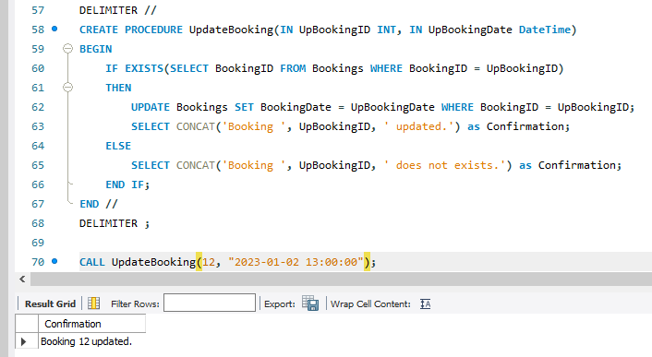

## ****Task 3****

For the third and final task, Little Lemon need you to create a new procedure called **CancelBooking** that they can use to cancel or remove a booking.

The procedure should have one input parameter in the form of booking id. You must also write a **DELETE** statement inside the procedure.

